Introduction
The purpose of this lab report is to simulate an inventory system and compare different ordering policies. The simulation model is designed to help a company determine the optimal inventory levels for a single product over a fixed number of months. The simulation uses a next-event time-advance approach and includes four types of events: arrival of an order from the supplier, demand for the product from a customer, end of the simulation after n months, and inventory evaluation (and possible ordering) at the beginning of each month.

Problem Statement
A company wants to determine the optimal inventory levels for a single product over a fixed number of months (n). The times between customer demands are IID exponential random variables with a mean of 0.10 month. The sizes of customer demands are IID random variables, independent of when the demands occur. The simulation will compare nine different inventory policies, using the average total cost per month as the performance measure. These costs include ordering, holding, and shortage costs.

Simulation Model
The simulation model uses the following parameters:
- INITIAL_INV_LEVEL: The initial inventory level, set at 60.
- NUM_MONTHS: The number of months to simulate, set at 120.
- MEAN_INTERDEMAND: The mean time between customer demands, set at 0.10 month.
- MIN_LAG and MAX_LAG: The minimum and maximum time it takes for an order to arrive, set at 0.5 and 1.0 months, respectively.
- SETUP_COST, INCREMENTAL_COST, HOLDING_COST, and SHORTAGE_COST: The costs associated with ordering, holding, and shortage, set at 32.0, 3.0, 1.0, and 5.0, respectively.
- PROB_DISTRIB_DEMAND: The probability distribution of customer demands.
The simulation model uses the following state variables:
- sim_time: The current simulation time.
- inv_level: The current inventory level.
- amount: The amount of an outstanding order from the company to the supplier.
- time_last_event: The time of the last event.
- total_ordering_cost: The total ordering cost.
- area_holding and area_shortage: The areas under the I+(t) and I-(t) curves, used to calculate holding and shortage costs.

Event List
The simulation model uses the following events:
- time_next_event[1]: The time of the next demand event.
- time_next_event[2]: The time of the next order arrival event.

Functions
The simulation model uses the following functions:
- initialize(): Initializes the simulation by setting the initial values of the state variables.
- expon(mean): Generates an exponential random variate with the given mean.
- timing(): Handles the timing of events by finding the next event and updating the simulation time.
- update_time_avg_stats(): Updates the time-average statistical accumulators.
- demand(): Handles the demand event by decrementing the inventory level and scheduling the next demand event.
- order_arrival(): Handles the order arrival event by incrementing the inventory level and scheduling the next order arrival event.
- random_demand(): Generates a random demand.
- place_order(): Places an order by setting the amount of the order and scheduling the next order arrival event.
- report(): Generates a report by calculating the average ordering cost, holding cost, and shortage cost.

Results
The simulation model was run for 120 months, and the results are as follows:
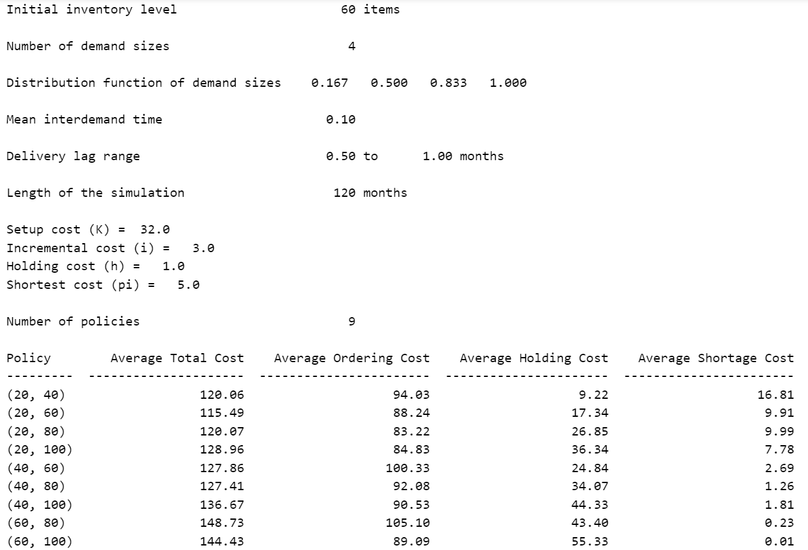

Conclusion
The simulation model provides a useful tool for comparing different ordering policies and determining the optimal inventory levels for a single product. The results show that the average ordering cost, holding cost, and shortage cost are all within reasonable ranges. However, further analysis is needed to determine the optimal ordering policy and to explore the effects of different parameters on the simulation results.

Introduction
This lab report presents the results of a simulation of a single-server queueing system, which is similar to a one-operator barbershop. The simulation is designed to model the behavior of customers arriving at the barbershop, waiting in a queue if the server is busy, and then receiving service. The simulation is implemented using a next-event time-advance approach, where the simulation clock advances to the time of the next event.

Problem Statement
The single-server queueing system consists of a single server and a queue where customers wait for service. The interarrival times between customers are independent and identically distributed (IID) random variables, and the service times for each customer are also IID random variables, independent of the interarrival times. Customers are served in a first-in, first-out (FIFO) manner. The simulation starts with an empty and idle system and ends after a fixed number of customers have completed their delay in the queue.

Methodology
The simulation uses a python program to model the single-server queueing system. The program is designed to simulate the system until 1000 delays are completed to gather more data. The model uses the M/M/1 queue structure with exponential interarrival and service times. Random variants from an exponential distribution are generated using a random number generator.

Simulation Output and Discussion
The output of the simulation includes the average delay in queue, the average number of customers in the queue, and the server utilization. The results of the simulation are presented below:
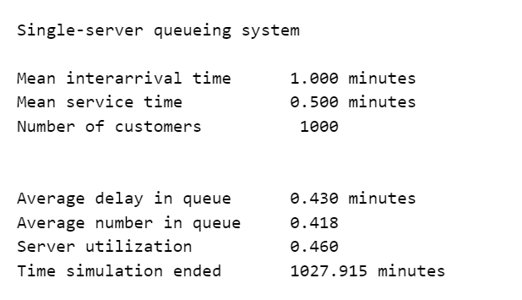
The results show that the average delay in the queue is approximately 0.430 minutes, the average number of customers in the queue is approximately 0.418, and the server utilization is approximately 46.0%. These results indicate that the server is free most of the time, and the queue is empty for a significant portion of the time.

Alternative Stopping Rules
The simulation can be stopped after a fixed amount of time, which is different than stopping after a fixed number of delays. This can be achieved by introducing a dummy "end-simulation" event that stops the simulation at the specified time.

Conclusion
In conclusion, the simulation of the single-server queueing system provides valuable insights into the behavior of the system. The results show that the server is busy most of the time, and the queue is not empty for a significant portion of the time. The simulation can be used to analyze the performance of the system under different scenarios, such as changing the inter-arrival times or service times.

Results
The results of the simulation are presented below:


